**international communications**

**30-day media report – Research article**

**Original paper:** **Every subcubic multigraph is (1,27)-packing edge-colorable**

**Journal:** Journal of Graph Theory

**Authors:** Xujun Liu, Michael Santana, Taylor Short

**Date Published:** 10 July 2023

**DOI:** <https://onlinelibrary.wiley.com/doi/10.1002/jgt.23004>

**Title of press release:** Joining the dots: Mathematicians solve hot coloring problem

**Date Published:** 15 September 2023

**URL:** <https://www.xjtlu.edu.cn/en/news/2023/09/joining-the-dots-mathematicians-solve-hot-coloring-problem>

**Total number of unique readers of the media outlets that picked up the article per month:**

8272330

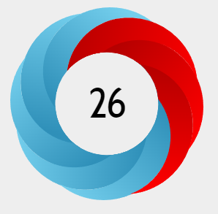**Altmetric score**

**In the top 5.8% of all research outputs scored by Altmetric.**

The Altmetric Attention Score for a research output provides an indicator of the amount of attention that it has received. The score is derived from an automated algorithm, and represents a weighted count of the amount of attention we've picked up for a research output.

**Number of media outlets that picked up the media release (excluding Chinese outlets):**

7

**Number of views of media release per site where it was uploaded:**

|  |  |  |
| --- | --- | --- |
| Website | Views | Social media shares |
| ScienceX | 10750 | 28 |
| EurekAlert | 606 | n/a |
| Alpha Galileo | 377 (journalists) | n/a |

Thanks for your support and we look forward to working with you again!

The International Communications Team